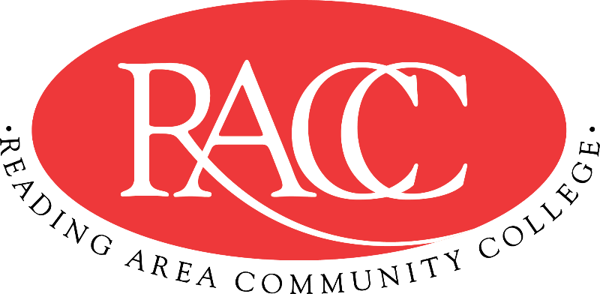

Transfer Guide
Reading Area Community College & Penn State Berks
A.A. in Communications |  |  | B.A. in Writing and Digital Media
Course | Name | CR | Equivalent Course/ Area Satisfied | CR
CSS 103 | College Success Strategies | 3 | 3 cr. PSU xfrGEN | 3
COM 121 | English Composition I | 3 | ENGL 15 (GWS) | 3
IFT 110 | Introduction to Information Technology | 3 | MIS 204 | 3
COM 221 | English Composition II | 3 | ENGL 202B (GWS) | 3
General Education: Humanities |  | 3 | General Education: Art (GA) | 3
Total Credits |  | 15 | Total Credits | 15
MAT 150 | Foundations of Mathematics | 3 | 3 cr. MATH xfrGQ1 (GQ) | 3
COM 151 | Fundamentals of Speech | 3 | CAS 100 | 3
ENG 125 | Introduction to Literature | 3 | ENGL 1 (GH) | 3
General Education:  Natural/Physical Sciences |  | 4 | General Education: Natural Sciences (GN) | 4
General Education:  Social Sciences |  | 3 | General Education: Social and Behavioral Science (GS) | 3
Total Credits |  | 16 | Total Credits | 16
General Education:  Natural/Physical Sciences |  | 3 | General Education: Natural Science (GN) | 3
COM 211 &  COM 215 &  COM 218 | Poetry Writing  Creative Nonfiction  Fiction Writing I | 9 | ENGL 214 (By Substitution) &  6 cr ENGL xfrGEN | 9
COM 161 | Mass Media | 3 | COMM xfrGA1 | 3
Total Credits |  | 15 | Total Credits | 15
COM 163 | Writing for the Media | 3 | COMM 234 (By Substitution) | 3
COM 201 | Introduction to Editing | 3 | COMM xfrGEN (Supporting Courses) | 3
COM 271 | Rhetorical Theory | 3 | ENGL 472 (By Substitution) | 3
COM 141 | Technical Writing | 3 | ENGL xfrGEN | 3
General Education:  Social Sciences |  | 3 | General Education: Humanities (GH) | 3
Total Credits |  | 15 | Total Credits | 15
Total Credits |  | 61 | Total Credits Transferable | 61

This Transfer Guide is designed for Penn State Berks ONLY. Students seeking transfer admission to any other campus should contact that campus directly.
This Transfer Guide may change without notice before the student is admitted to Penn State Berks. RACC students should confirm their academic plans with the Transfer Admissions Counselor at Penn State Berks: 610-396-6060 or berkstransfer@psu.edu. Following this Transfer Guide does not guarantee admission or transfer of credit to Penn State Berks.

