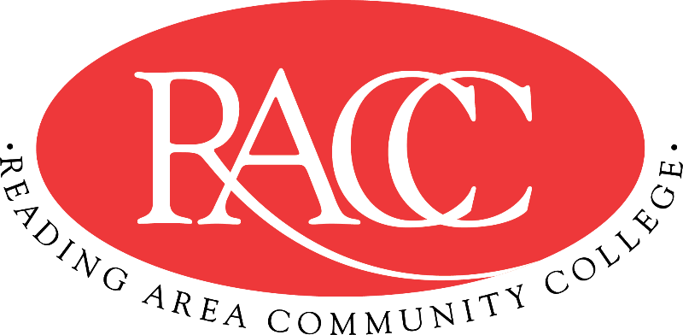

Transfer Guide
Reading Area Community College & Penn State Berks
A.G.S. in General Studies |  |  | B.S. in Elementary & Early Childhood Education
Course | Name | CR | Equivalent Course/ Area Satisfied | CR
CSS 103 | College Success Strategies | 3 | 3 cr. PSU xfrGEN | 3
COM 121 | English Composition I | 3 | ENGL 15 (GWS) | 3
ECE 115 | Integrated Arts in ECE | 3 | General Education: Arts (GA) | 3
PSY 130 | General Psychology | 3 | PSYCH 100 (Elective) | 3
EDTHP 115A  at PSU via Cross Registration | Education in American Society | 3 | EDTHP 115A  at PSU via Cross Registration | 3
Total Credits |  | 15 | Total Credits | 15
COM 151 | Fundamentals of Speech | 3 | CAS 100 (GWS) | 3
PSY 240 | Educational Psychology | 3 | EDPSY 14 | 3
HIS 110 or HIS 115 | History of the United States I or II | 3 | HIST 20 (GH) or HIST 21 (GH) | 3
CHE 120 | Principles of Chemistry | 4 | CHEM 3 (GN) + 1 cr. CHEM xfrGN1 | 4
CI 295A  at PSU via Cross Registration | Introductory Field Experience for Teacher Preparation | 3 | CI 295A  at PSU via Cross Registration | 3
Total Credits |  | 16 | Total Credits | 16
COM 221 | English Composition II | 3 | ENGL 202B (GWS) | 3
MAT 210 | Statistics | 3 | STAT 100 (GQ) (by Substitution) | 3
PSY 210 | Child Psychology | 3 | HDFS 229 (by Substitution) | 3
ECE 140 | Health, Safety & Physical Ed. | 3 | 3 cr. ECE xfr100 (GHW) (by Substitution) | 3
SOC 220 | The Family | 3 | SOC 30 | 3
MATH 200  at PSU via Cross Registration | Problem Solving in Mathematics I | 3 | MATH 200  at PSU via Cross Registration | 3
Total Credits |  | 18 | Total Credits | 18
ENG 125 | Introduction to Literature | 3 | ENGL 1 (GH) | 3
BIO 120 | Biological Concepts | 4 | BIOL 11 + BIOL 12 (GN) | 4
General Education: Arts (GA) |  | 3 | General Education: Arts (GA) | 3
ENV 130 | The Environment | 3 | BISC 3 (GN) | 3
GEOG 30N  at PSU via Cross Registration | Environment and Society in a Changing World | 3 | GEOG 30N (GN/GS)  at PSU via Cross Registration | 3
Total Credits |  | 16 | Total Credits | 16
Total Credits |  | 65 | Total Credits Transferable | 65

This Transfer Guide is designed for Penn State Berks ONLY. Students seeking transfer admission to any other campus should contact that campus directly.
This Transfer Guide may change without notice before the student is admitted to Penn State Berks. Students should confirm their academic plans with Transfer Admissions at Penn State Berks: 610-396-6060 or berkstransfer@psu.edu. Following this Transfer Guide does not guarantee admission or transfer of credit to Penn State Berks.

